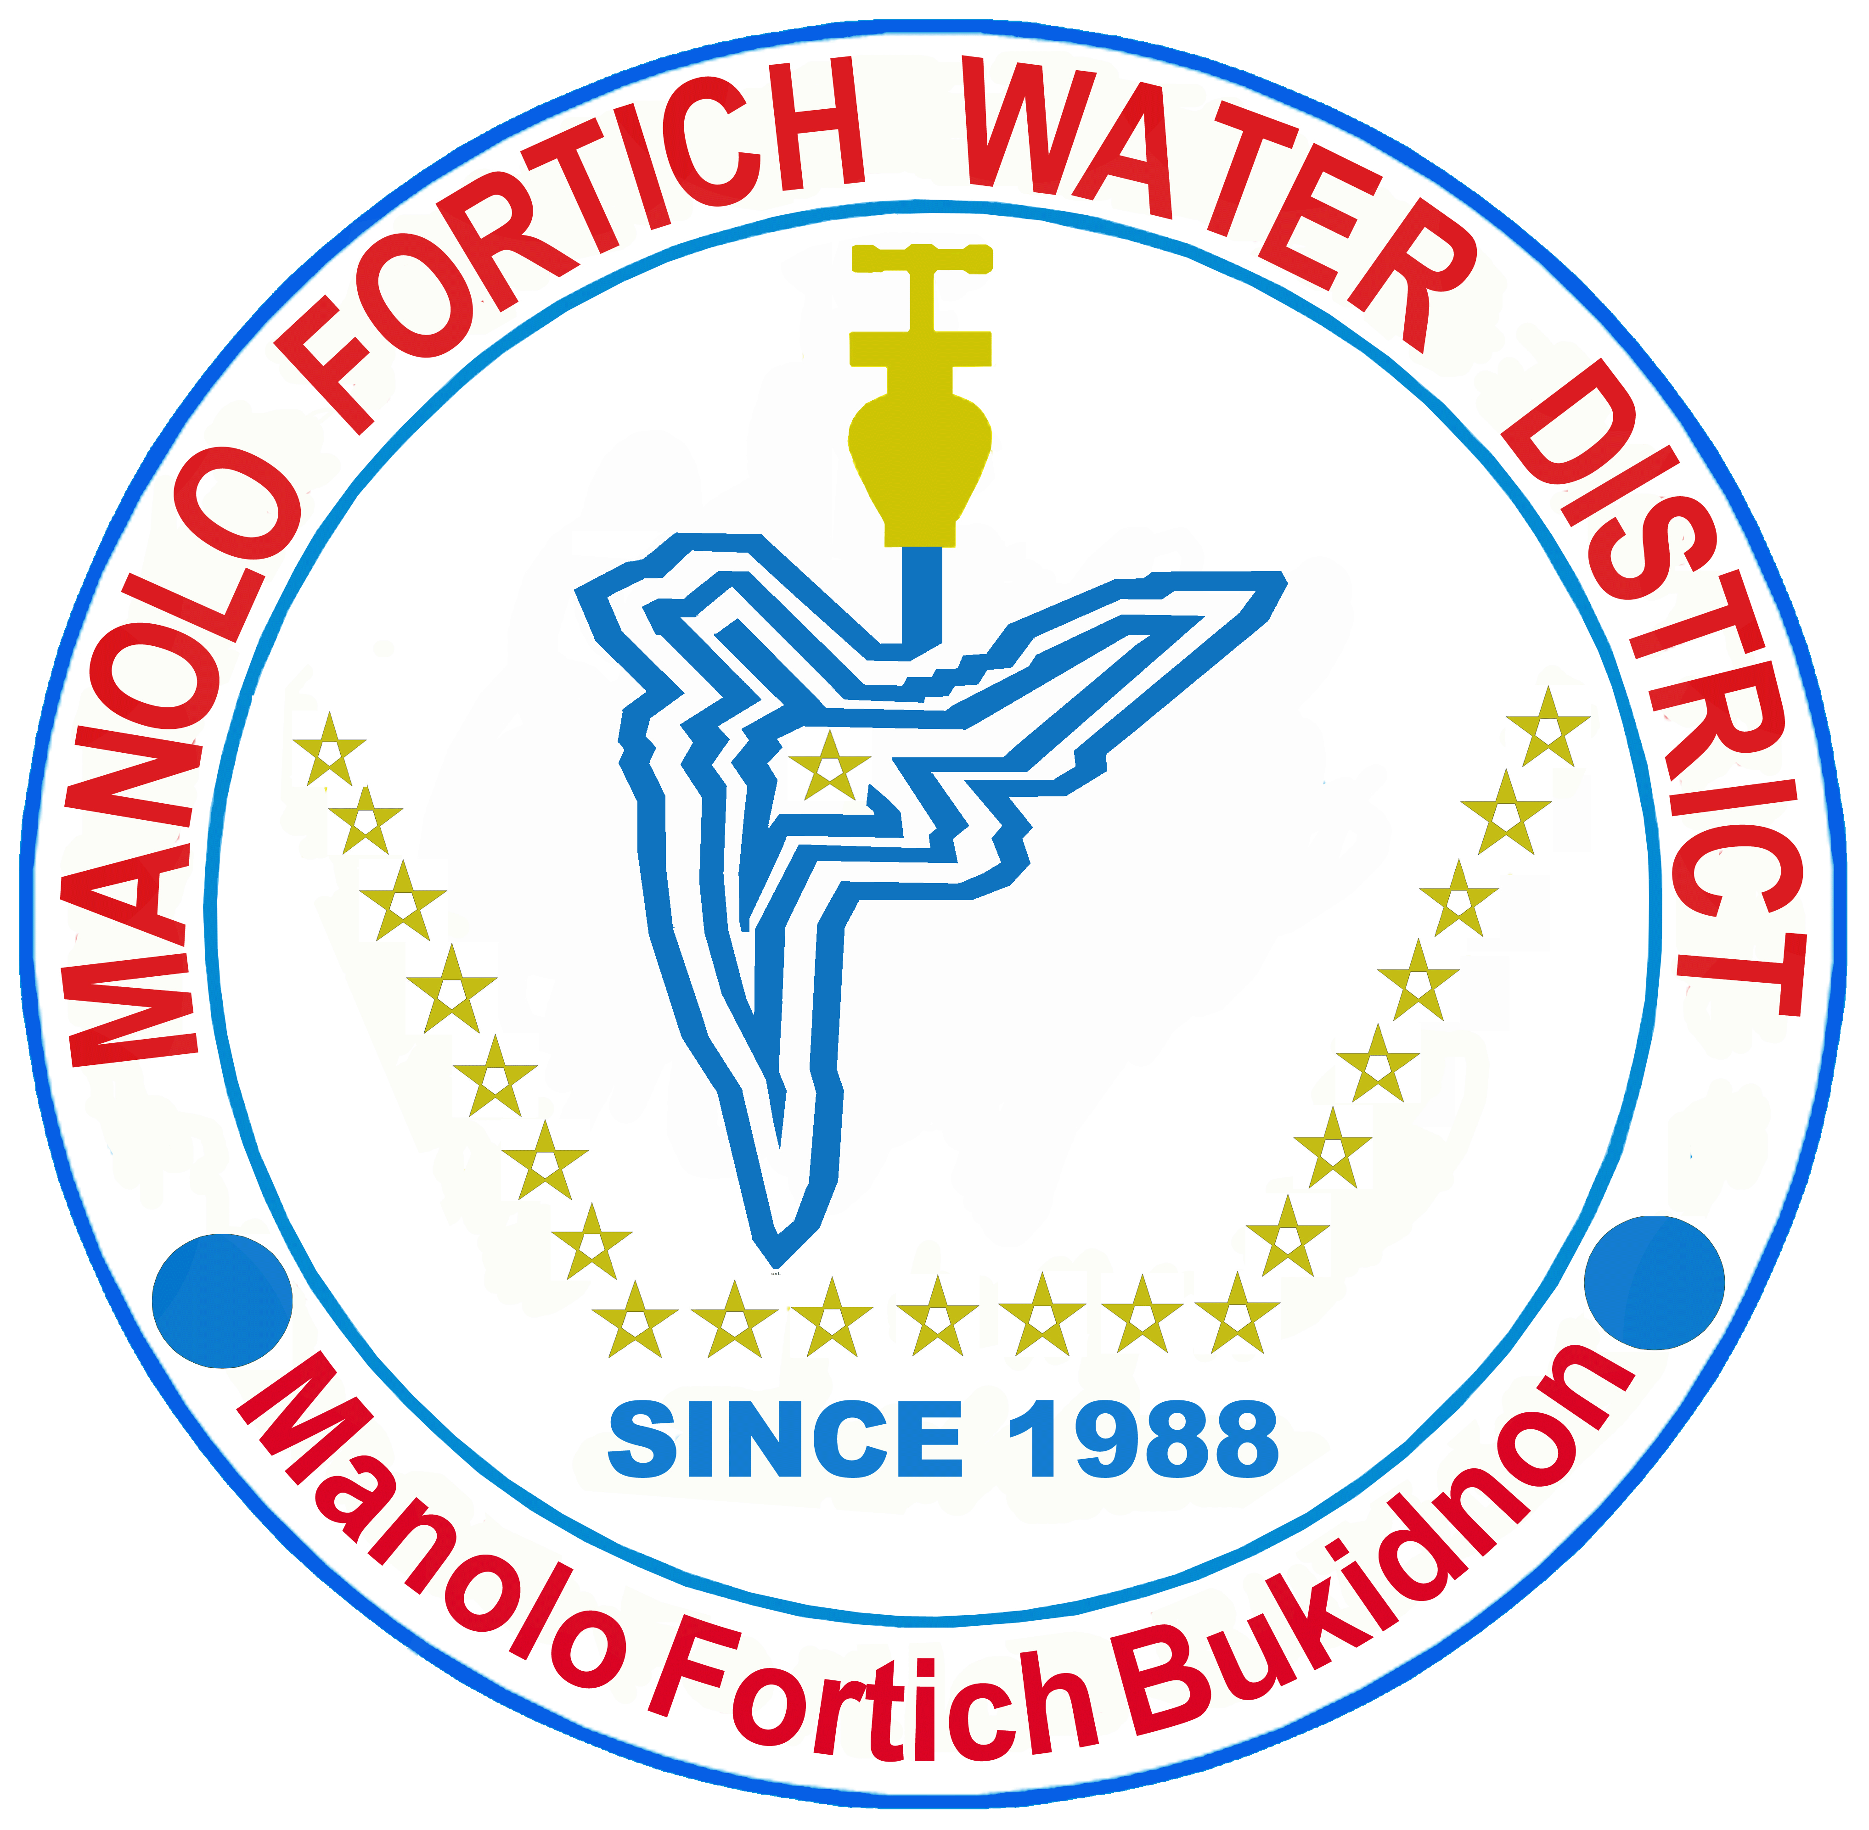Manolo Fortich Water District

Manolo Fortich, Bukidnon

[mfwd_buk@yahoo.com](mailto:mfwd_buk@yahoo.com) / 0917-7181311

**BIDS and AWARDS COMMITTEE**

Name of Project: *Supply and Delivery of 2”, 3” and 6” Diameter Series 8 uPVC Pipes*

Approved Budget for the Contract: One Million Three Hundred Seventy Six Thousand Seven Hundred Forty Three Pesos (P 1,376,743.00)

**ADDENDUM # 1**

This addendum Number 1 is issued to modify or omit item in the Bid Documents. The following will be omitted as requirement on this bidding:

* 1. As indicated in the BDS, ITB Clause Number 5.3, item Letter C, stating “Bidder must show one proof of two years warranty extension and one proof for three years warranty extension to any government entity” will be omitted and not included as requirement of this bidding.

1. For guidance and information of all concerned.

ENGR. ERMITO L. GANAS (sgd)

BAC Chairman

October 13, 2017